Columbia River
Online Registration:

Re
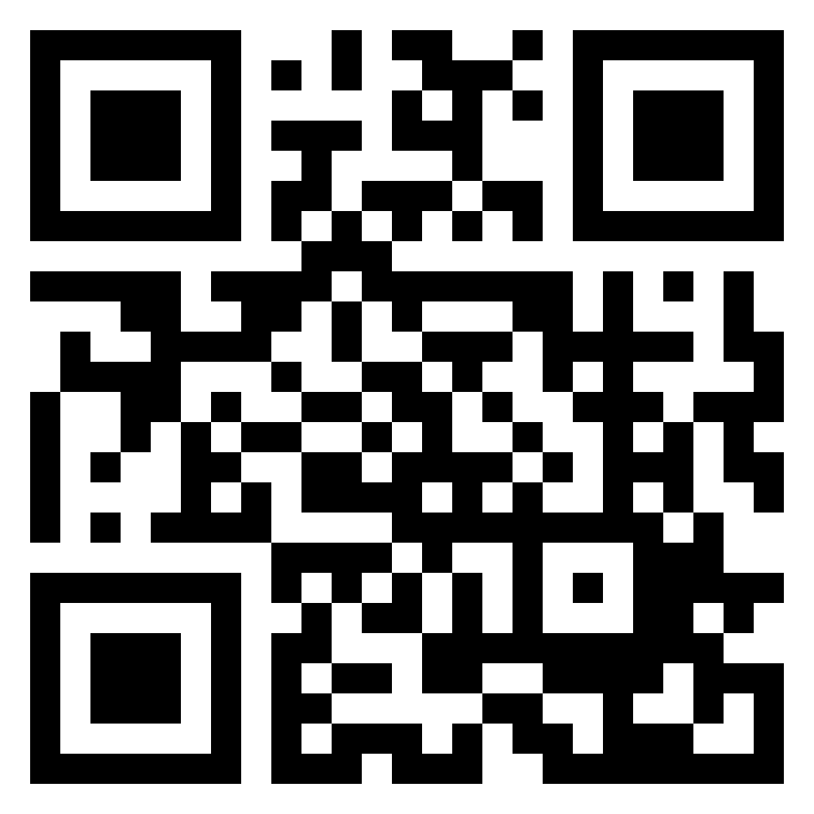
June 17-21, 2024
9am to 12:00PM
Grades 1-5
Bible Church
1 Vacation Bible School
Registration Form

Name ___________________________________________________ Child’s Gender_______
Child’s Age __________ Date of Birth _____________ Last grade completed ______________
Name of Parent(s) _____________________________________________________________
Street Address ________________________________________________________________
City ___________________________________________ State _________ Zip_____________
Phone number____________________ Email address_________________________________
Home Church__________________________________________________________________
Allergies, medical conditions, or special needs_______________________________________
Emergency Contact______________________________________Phone__________________
Relationship to child____________________________________________________________
Who has permission to pick up child from VBS _______________________________________
Permission to use photographs:
_____Yes, photos may be used _____No, photos may not be used
I agree that Columbia River Bible Church may use such photographs of my child for any lawful purpose, including for example publicity, illustration, advertising and website content.

Parent Signature (Required) ___________________________________________Date________________
509.738.6632 mycrbc.org

4/22/2024DY

