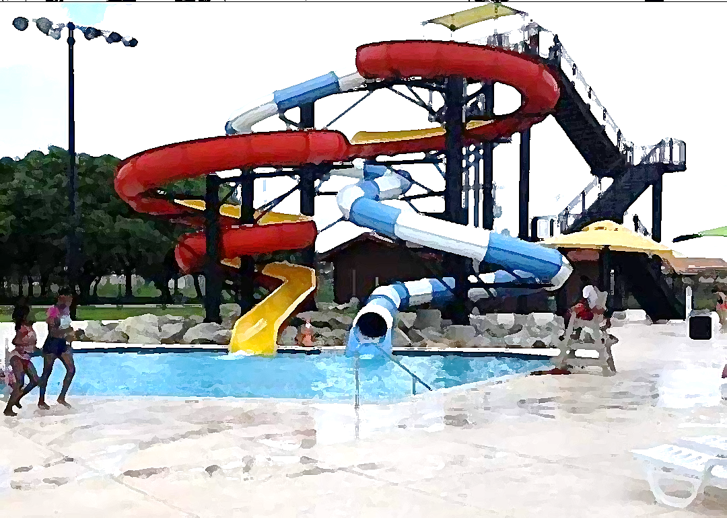
Mem1 at the Water Park
Friday, July 15 at 6:30 PM to 8:30 PM
At the Nessler Family Aquatic Center
1700 5th Avenue North in Texas City

We have the place reserved for our church family and friends,
INCLUDING ALL YOUTH WHO HAVE PARTICIPATED IN VBS
OR OTHER PROGRAMS AT MEM1!
(Must be accompanied by parent)
There will be water slides and food. Lifeguards will be on duty.

IT’S ALL FREE!
Sponsored by the Team Trivia Challenge
Extending an invitation to the youth of our community.
RSVP to Paula at Presbyoffice@mem1.org 409-945-2931

